## Revision History

|  |  |  |  |
| --- | --- | --- | --- |
| **Date** | **Revision** | **Author** | **Changes** |
| 2022/2/22 | 1.0 | ZhangSheng | Initial version. |

## IP Description: (讲清楚IP的工作方式)

TIM1 ( Advanced timer )

TIM2~4 ( General-purpose timer )

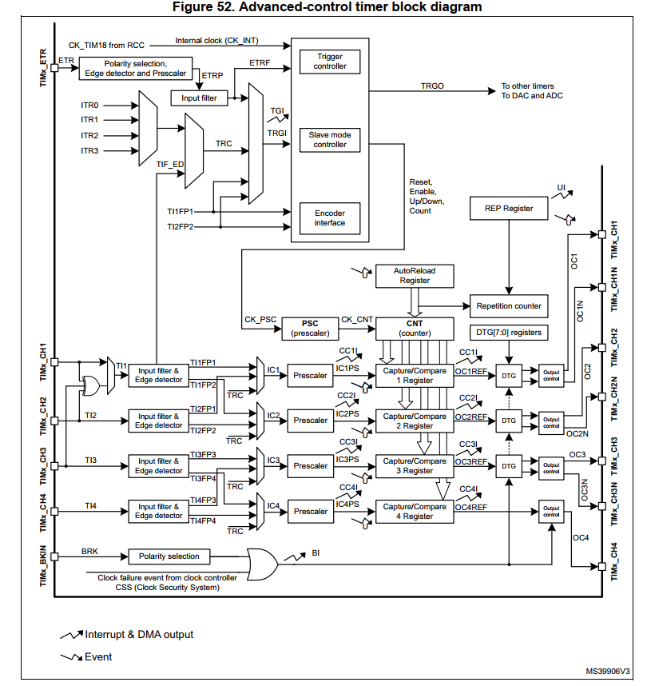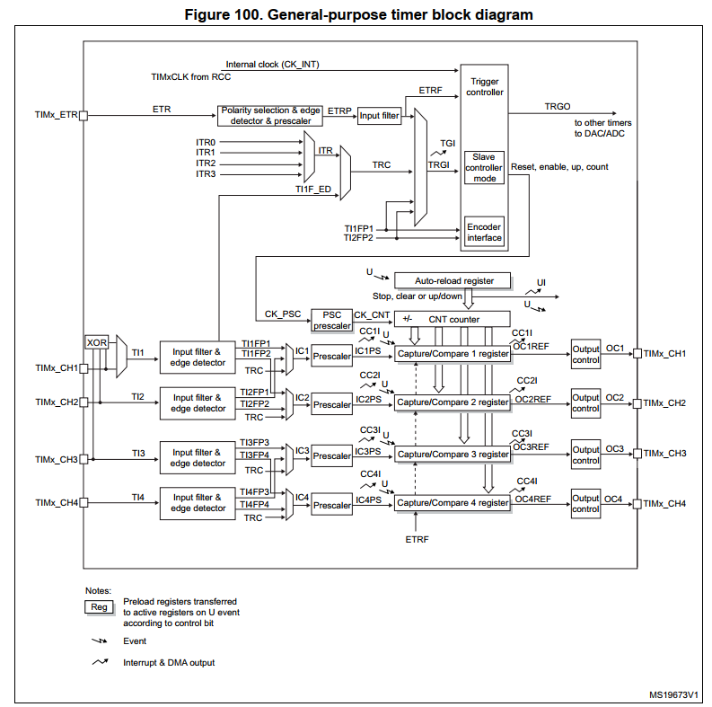

## Feature set: （功能列表）

* 16bit up,dowm, up/down auto-reload counter.
* 16-bit programmable prescaler allowing dividing (also “on the fly”) the counter clock

frequency either by any factor between 1 and 65536.

* Up to 4 independent channels for:
  + Input capture
  + Output compare
  + PWM generation (Edge and Center-aligned Mode)
  + One-pulse mode output
* Complementary outputs with programmable dead-time.
* Synchronization circuit to control the timer with external signals and to interconnect

several timers together.

* Repetition counter to update the timer registers only after a given number of cycles of

the counter.

* Break input to put the timer’s output signals in reset state or in a known state.
* Interrupt/DMA generation on the following events:
  + Update: counter overflow/underflow, counter initialization (by software or

internal/external trigger).

* + Trigger ‘’(counter start, stop, initialization or count by internal/external trigger).
  + Input capture.
  + Output compare.
  + Break input.
* Supports incremental (quadrature) encoder and hall-sensor circuitry for positioning

Purposes.

* Trigger input for external clock or cycle-by-cycle current management.

## Feature comparison with STM32: （跟STM32的功能比较）

**Chip-Platform:**

|  |  |  |
| --- | --- | --- |
| 符号描述：   1. ✅支持 2. ❌不支持 3. ❌硬件有，但SDK计划不支持 | At103 | STM32 |
| 输入捕获/输出比较/PWM/基本定时 | ✅ | ✅ |
| 刹车功能 | ✅ | ✅ |
| 多种时钟模式（外部时钟，内部时钟） | ✅ | ✅ |
| 死区可编程的互补输出 | ✅ | ✅ |
| 霍尔接口 | ✅ | ✅ |
| 中断/DMA | ✅ | ✅ |

## API Design: （分类列出会实现的API, API尽量一样）

|  |  |  |
| --- | --- | --- |
|  | 103 | STM32 |
| init/de-init | TIM_DeInit  TIM_TimeBaseInit  TIM_OCxInit (x =1 2 3 4)  TIM_ICInit  TIM_TimeBaseStructInit  TIM_OCStructInit  TIM_ICStructInit  TIM_BDTRStructInit |  |
| Config | TIM_PWMIConfig  TIM_BDTRConfig  TIM_ITConfig  TIM_DMAConfig  TIM_InternalClockConfig  TIM_ITRxExternalClockConfig  TIM_TIxExternalClockConfig  TIM_ETRClockMode1Config  TIM_ETRClockMode2Config  TIM_ETRConfig  TIM_PrescalerConfig  TIM_CounterModeConfig  TIM_EncoderInterfaceConfig  TIM_ForcedOCxConfig (x =1 2 3 4)  TIM_ARRPreloadConfig  TIM_OCxPreloadConfig (x =1 2 3 4)  TIM_OCxFastConfig (x =1 2 3 4)  TIM_OCxPolarityConfig (x =1 2 3 4)  TIM_OCxNPolarityConfig （x=1 2 3）  TIM_UpdateDisableConfig  TIM_UpdateRequestConfig |  |
| Set/Clear/Get/Ctrl | TIM_SelectHallSensor  TIM_SelectOnePulseMode  TIM_SelectSlaveMode  TIM_SelectMasterSlaveMode  TIM_SelectOutputTrigger  TIM_SelectInputTrigger  TIM_SelectCOM  TIM_SelectCCDMA  TIM_SelectOCxM  TIM_CtrlPWMOutputs  TIM_CCPreloadControl  TIM_GenerateEvent  TIM_SetCounter  TIM_SetAutoreload  TIM_SetComparex (x =1 2 3 4)  TIM_SetICxPrescaler (x =1 2 3 4)  TIM_SetClockDivision  TIM_GetCapturex (x =1 2 3 4)  TIM_GetCounter  TIM_GetPrescaler  TIM_ClearOCxRef (x =1 2 3 4) |  |
| Cmd（Enable/Disable） | TIM_Cmd  TIM_DMACmd  TIM_CCxCmd  TIM_CCxNCmd |  |
| FlagStatus | TIM_GetFlagStatus  TIM_ClearFlag  TIM_GetITStatus  TIM_ClearITPendingBit |  |

## Data structure design:

typedef struct

{

  uint16_t TIM_Prescaler;         /*!< Specifies the prescaler value used to divide the TIM clock.

                                       This parameter can be a number between 0x0000 and 0xFFFF */

  uint16_t TIM_CounterMode;       /*!< Specifies the counter mode.

                                       This parameter can be a value of @ref TIM_Counter_Mode */

  uint16_t TIM_Period;            /*!< Specifies the period value to be loaded into the active

                                       Auto-Reload Register at the next update event.

                                       This parameter must be a number between 0x0000 and 0xFFFF.  */

  uint16_t TIM_ClockDivision;     /*!< Specifies the clock division.

                                      This parameter can be a value of @ref TIM_Clock_Division_CKD */

  uint8_t TIM_RepetitionCounter;  /*!< Specifies the repetition counter value. Each time the RCR downcounter

                                       reaches zero, an update event is generated and counting restarts

                                       from the RCR value (N).

                                       This means in PWM mode that (N+1) corresponds to:

                                          - the number of PWM periods in edge-aligned mode

                                          - the number of half PWM period in center-aligned mode

                                       This parameter must be a number between 0x00 and 0xFF.

                                       @note This parameter is valid only for TIM1 and TIM8. */

} TIM_TimeBaseInitTypeDef;

typedef struct

{

  uint16_t TIM_OCMode;        /*!< Specifies the TIM mode.

                                   This parameter can be a value of @ref TIM_Output_Compare_and_PWM_modes */

  uint16_t TIM_OutputState;   /*!< Specifies the TIM Output Compare state.

                                   This parameter can be a value of @ref TIM_Output_Compare_state */

  uint16_t TIM_OutputNState;  /*!< Specifies the TIM complementary Output Compare state.

                                   This parameter can be a value of @ref TIM_Output_Compare_N_state

                                   @note This parameter is valid only for TIM1 and TIM8. */

  uint16_t TIM_Pulse;         /*!< Specifies the pulse value to be loaded into the Capture Compare Register.

                                   This parameter can be a number between 0x0000 and 0xFFFF */

  uint16_t TIM_OCPolarity;    /*!< Specifies the output polarity.

                                   This parameter can be a value of @ref TIM_Output_Compare_Polarity */

  uint16_t TIM_OCNPolarity;   /*!< Specifies the complementary output polarity.

                                   This parameter can be a value of @ref TIM_Output_Compare_N_Polarity

                                   @note This parameter is valid only for TIM1 and TIM8. */

  uint16_t TIM_OCIdleState;   /*!< Specifies the TIM Output Compare pin state during Idle state.

                                   This parameter can be a value of @ref TIM_Output_Compare_Idle_State

                                   @note This parameter is valid only for TIM1 and TIM8. */

  uint16_t TIM_OCNIdleState;  /*!< Specifies the TIM Output Compare pin state during Idle state.

                                   This parameter can be a value of @ref TIM_Output_Compare_N_Idle_State

                                   @note This parameter is valid only for TIM1 and TIM8. */

} TIM_OCInitTypeDef;

typedef struct

{

  uint16_t TIM_Channel;      /*!< Specifies the TIM channel.

                                  This parameter can be a value of @ref TIM_Channel */

  uint16_t TIM_ICPolarity;   /*!< Specifies the active edge of the input signal.

                                  This parameter can be a value of @ref TIM_Input_Capture_Polarity */

  uint16_t TIM_ICSelection;  /*!< Specifies the input.

                                  This parameter can be a value of @ref TIM_Input_Capture_Selection */

  uint16_t TIM_ICPrescaler;  /*!< Specifies the Input Capture Prescaler.

                                  This parameter can be a value of @ref TIM_Input_Capture_Prescaler */

  uint16_t TIM_ICFilter;     /*!< Specifies the input capture filter.

                                  This parameter can be a number between 0x0 and 0xF */

} TIM_ICInitTypeDef;

typedef struct

{

  uint16_t TIM_OSSRState;        /*!< Specifies the Off-State selection used in Run mode.

                                      This parameter can be a value of @ref OSSR_Off_State_Selection_for_Run_mode_state */

  uint16_t TIM_OSSIState;        /*!< Specifies the Off-State used in Idle state.

                                      This parameter can be a value of @ref OSSI_Off_State_Selection_for_Idle_mode_state */

  uint16_t TIM_LOCKLevel;        /*!< Specifies the LOCK level parameters.

                                      This parameter can be a value of @ref Lock_level */

  uint16_t TIM_DeadTime;         /*!< Specifies the delay time between the switching-off and the

                                      switching-on of the outputs.

                                      This parameter can be a number between 0x00 and 0xFF  */

  uint16_t TIM_Break;            /*!< Specifies whether the TIM Break input is enabled or not.

                                      This parameter can be a value of @ref Break_Input_enable_disable */

  uint16_t TIM_BreakPolarity;    /*!< Specifies the TIM Break Input pin polarity.

                                      This parameter can be a value of @ref Break_Polarity */

  uint16_t TIM_AutomaticOutput;  /*!< Specifies whether the TIM Automatic Output feature is enabled or not.

                                      This parameter can be a value of @ref TIM_AOE_Bit_Set_Reset */

} TIM_BDTRInitTypeDef;

## Known behavior and issue.